A BOAT TO THE EUROPEAN PARLIAMENT
Ferry Not Frontex

Docking on the 10th of June 2015
Support the immigrants' demands

Assembly in front of the Human Rights Palace Strasbourg * at 16.30
EVERYONE COME AND SHARE!

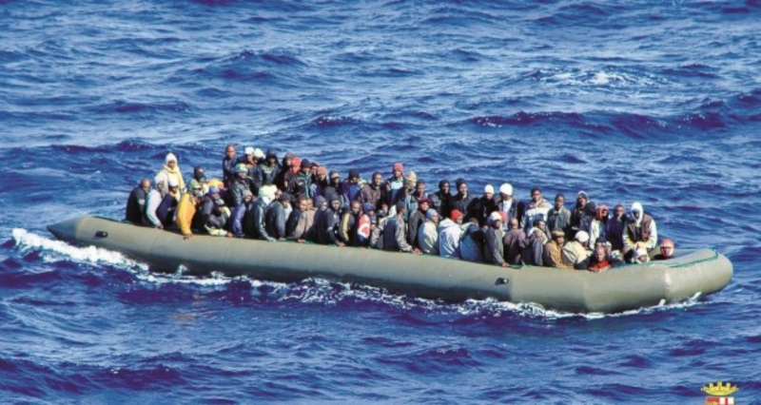
Stop the shipwrecks and disappearance of immigrants at sea

The thousands of dead immigrants at sea are a direct consequence of the immigration policies of the European Union

We denounce :
- A Europe blinded by the murdering obsession of security
- The outsourcing of european immigration policy to the other side of the Mediterranean, which leads to serious violations of human rights and dignity
- The egoism and hypocrisy of european states, who refused to help Italy carry on with the operation Mare Nostrum

We fight :
- For the abolition of the Frontex agency, which is partly responsible for the repeated shipwrecks in the Mediterranean. Frontex doesn't have the objective of saving human lives but of intercepting and controlling individuals
« To keep under surveillance is not to cater for »
- For the allocation of security policy funds to solidarity instead
- For the transformation of the euro-mediterranean zone from a regime of murdering borders into a zone of solidarity and right to protection
- For the freedom of movement

To stop the massacre, the logic of Fortress Europe must be inverted and give place to international mobility, authorise the access to european territory and respect the laws of international protection.
It is under the pretext of collaboration and development aid that Europe finances further means of repression and detention camps.
And it is Frontex under bilateral agreements, which favours this policy without democratic control by the European Parliament.
We demand from the Members of the European Parliament to remain vigilant against Frontex actions and to exercise their democratic control.

For a solidary Mediterranean
For the freedom of movement
Against the violation of International Law

Action organized by :
Atmf, Attac Strasbourg, D’ailleurs Nous Sommes d’Ici, la Cimade, Watch the Med Alarme Phone, Npa 67, Welcome to Europe, Afrique Europe Interact.
Supported by :
Udees, Ujfp-Alsace, Collectif Judéo Arabe et Citoyen pour la Palestine, Teje, Mrap, Cares, , le Conseil des Migrants Subsahariens au Maroc, Cispm Maroc, All Included Amsterdam, Mouvement des jeunes communistes du Bas-Rhin, Union des étudiants communistes de Strasbourg, Terre pour Tous (Tunisie), Voix des Migrants et CISPM/Berlin
Contact :atmf.strasbourg@gmail.com
* Going : Allée des Droits de l'Homme, Fr-67000 Strasbourg - tram E station "Droits de l'Homme" ; bus stop 6-30-72 arrêt "Conseil de l'Europe"

